**Topic: Exploring nature with all five senses**

**Module:** Products of Nature

**Age:** 4-5 years

**Time**: about 1 hour

**Aim:** Students will learn about their five primary senses. They will learn to localize organs of these senses on their bodies, name them, and use them to explore nature around the school. They should enjoy having a short walk outdoors, playing a simple game, and tasting fruits and vegetables.

**Equipment:**

A bowl of various fruits and vegetables cut into small pieces

Forks

**Preparation in advance**:

Teachers prepare a bowl of 3-4 kinds of fruits and vegetables, cut into small pieces.

**Description of the activity**:

**Note**: the following activities will require students to describe what they see, hear, smell, taste, and feel. The students at this age still do not possess sufficient vocabulary, especially if the official language used in the school differs from the students’ native language (mother tongue). It is therefore highly recommended to use the students’ native language to allow them to describe more easily what they perceive.

***Part one: 5 senses in our body***

1. Obsah obrázku oblečení, venku, tráva, osoba

   Popis byl vytvořen automatickyThe teacher asks students what parts of our body we use to sense the world around us. He/she first lets the student express their opinions before he/she helps them name their senses and sensory organs. The assistant writes down students’ responses.
2. The teacher then names the sense of sight. He/she asks students to say what part of our body helps us to see and what we can sense with our sense of sight. The assistant writes down students’ responses.
3. Obsah obrázku oblečení, venku, tráva, osoba

   Popis byl vytvořen automatickyThe teacher then names the sense of hearing. He/she asks students to say what part of our body helps us to hear and what we can sense by our hearing. The assistant writes down students’ responses.
4. The teacher then names the sense of smell. He/she asks students to say what part of our body helps us to smell and what we can sense by our smell. The assistant writes down students’ responses.
5. The teacher then names the sense of taste. He/she asks students to say what part of our body helps us to taste and what we can sense by our taste. The assistant writes down students’ responses.
6. Obsah obrázku venku, oblečení, osoba, chlapec

   Popis byl vytvořen automatickyThe teacher then names the sense of touch. He/she asks students to say what part of our body helps us to touch and what we can sense by our touch. The assistant writes down students’ responses. (The students can speak either about their hands or about their skin; both can be considered as correct)
7. The teacher then names the senses in random order and asks the students to show the part of the body where the sense resides. He/she increases the speed of naming the senses as long as the students can respond. The assistant records the game on video.

***Part 2. Exploring nature with all five senses***

1. Obsah obrázku venku, tráva, obloha, osoba

   Popis byl vytvořen automatickyThe teacher tells students that now they will use all their senses to explore nature around the school. They go for a brief walk to the schoolyard and around.
2. The teacher asks students to use their eyes and to tell everything they can see in nature around them. They encourage them to say what they see around them - not just to name the objects, but also to describe their colors and shapes. The assistant writes down students’ responses.
3. The teacher asks students to use their ears and to tell all the sounds they can hear in nature around them. The assistant writes down students’ responses.
4. The teacher asks students to use their noses and to tell everything they can smell in nature around them. They may say if they like these smalls or not. The assistant writes down students’ responses.
5. The teacher asks students to use their hands to touch some of the natural objects and to describe how they feel them. The assistant writes down students’ responses.
6. 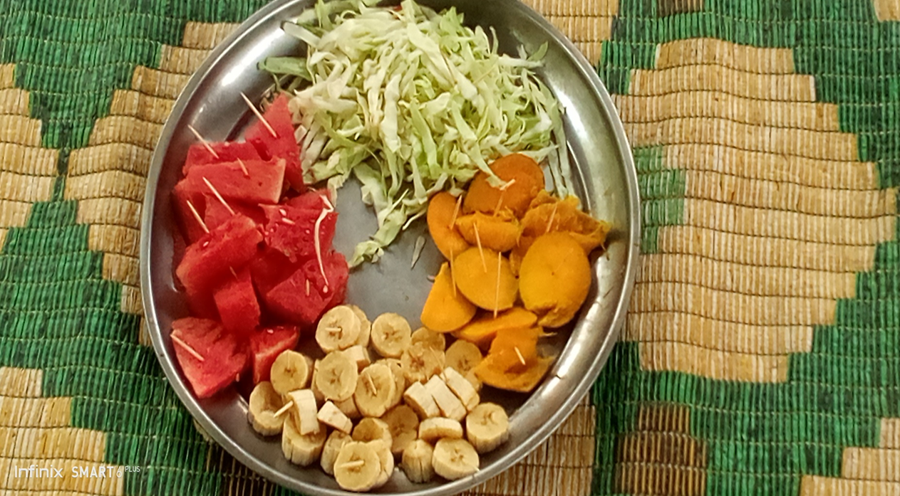At the end, the assistant brings a bowl of cut fruits and vegetables. The teacher invites students to taste the food, using forks or clean hands, and to describe how it tastes on their tongue.

**Note:** Do not show the students the fruits until you have finished all other activities. Students may get distracted, and they may think of eating fruits instead of exploring other objects. Hide the fruits from students and concentrate first on looking for sights, sounds, smells, and touches around the school. Only at the end, as a surprise, offer the students a taste of the fruits.

***Part 3: Repetition***

Before the activity ends, the teacher again starts naming all senses in random order and asks the students to show the part of the body where the sense resides. He/she increases the speed of naming the senses as long as the students can respond.